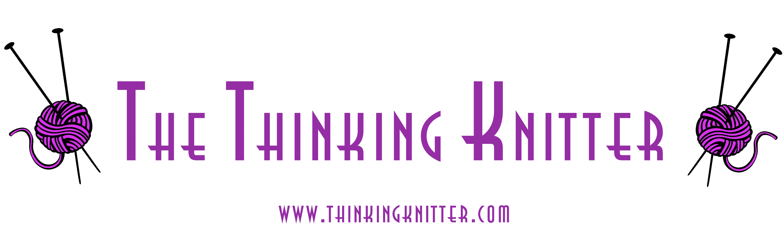 | To order, print this page and send with a check or money order in U. S. funds to:  The Thinking Knitter  Rae B. Creedle  1126 Sixth St. SE  Roanoke, VA 24013

Please print clearly.

Name
Address
City |  | State/Province
Zip/Postal Code |  | Country
Email address

Quantity | Item | Amount | Total
 | Felted Round Bag | $6.00
 | Felted Project Pouch | $6.00
 | Total for patterns
 | Virginia residents only add 5% sales tax on total for patterns
Shipping to U. S. and Canada:
$1.00 for the first pattern, $.25 for each additional pattern
 | Grand Total

Returns policy:

Patterns may not be returned. Defective patterns will be replaced.

